**MySQL Day2**

**Code For Creating the Database for Guvi**

create database guvi;

use guvi;

Student Information Table:

create table studentInfo(

studentName varchar(255) not null,

studentId integer not null primary key,

stuEmail varchar(255) not null,

stuMobileNumber varchar(255) not null,

batchId integer not null,

batchName varchar(255) not null

);

Task Information Table:

create table task(

taskId integer not null,

taskName varchar(255) not null,

batchId integer not null

);

Mentor Information Table:

create table mentor(

mentorId integer not null primary key,

mentorName varchar(255) not null,

mentorEmail varchar(255) not null

);

Placement Information Table:

create table placement(

driveId integer not null auto_increment primary key,

companyName varchar(255) not null,

studentId integer, foreign key(studentId) references studentInfo(studentId),

drive_date date not null

);

Queries Table:

create table queries(

queryId integer not null,

queryname varchar(255) not null,

studentId integer, FOREIGN key(studentId) references studentInfo(studentId),

mentorId integer, foreign key(mentorId) references mentor(mentorId)

);

Mock Interview Information Table:

create table mockInterviewInfo(

studentId integer, FOREIGN key(studentId) references studentInfo(studentId),

mentorId integer, foreign key(mentorId) references mentor(mentorId),

batchId integer, foreign key(batchId) references batchInfo(batchId)

);

Batch Information Table:

create table batchInfo(

batchId integer not null primary key,

batchName varchar(255) not null,

totalStudents integer not null

);

**Value Insertion queries for all tables:**

insert into studentInfo values("Kavipriya S",1,"kavi@gmail.com",2345678,1,"b53"),

("Hari R",2,"hari@gmail.com",238765,2,"b53"),

("prakash S",3,"prakash@gmail.com",265432,3,"b53"),

("mouriya S",4,"mouri@gmail.com",234987654,4,"b53");

insert into task(taskId,taskName) values(1,"task 1"),

(2,"task 2"),

(3,"task 3"),

(4,"task 4");

insert into mentor values(1,"Anitha","anitha@gmail.com"),

(2,"Prem","prem@gmail.com"),

(3,"Ganesh","ganesh@gmail.com"),

(4,"manikandan","manikandan@gmail.com");

insert into placement(driveId,companyName,drive_date) values(1,"zoho","2024-02-1"),

(2,"Google","2024-02-2"),

(3,"Microsoft","2024-02-3"),

(4,"IBM","2024-02-4");

insert into queries(queryId,queryname) values(1,"query 1"),

(2,"query 2"),

(3,"query 3"),

(4,"query 4");

insert into batchInfo values(1,"batch 1",50),

(2,"batch 2",70),

(3,"batch 3",90),

(4,"batch 4",60);

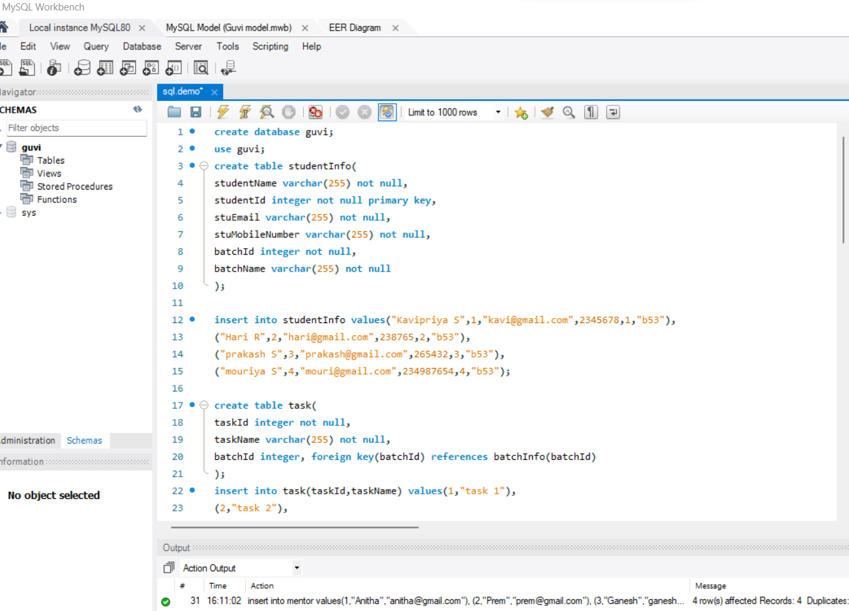

Entity Relationship Diagram:

